First of all, we would like to thank the Program Chairs for kind consideration of our paper for reviewing, and all the reviewers for highlighting certain important issues about our manuscript. With due respect to the reviewers, may we state that the current version of the manuscript has been modified based on the suggestions of the reviewers. Replies to the reviewers' comments are also listed below:

----------------------------------------------------------------------------------------------------------------

**Reviewer #1**

Q-1. For a more thorough review of COVID-19 related AI studies, the authors may cite this paper, which is a comprehensive systematic review of related studies:  
Roberts, Michael, et al. "Machine learning for COVID-19 detection and prognostication using chest radiographs and CT scans: a systematic methodological review." arXiv preprint arXiv:2008.06388 (2020).

**Response:** Thank you for suggesting such an insightful review paper on COVID-19 related AI studies. We have modified the **Related Work** section of our manuscript, citing the above mentioned paper and also other relevant research articles which are also mentioned in the review paper you suggested, to present an overview of previously done work for diagnosis of COVID-19 using deep learning techniques. For a quick view, we highlighted (Roberts, Michael, et al., 2020) in our manuscript.

Q-2. The authors have mentioned that the major challenge of the problem is that "large dataset of CT-scan images are not publicly available due to privacy concerns and obtaining very accurate model becomes difficult". As the author proposed the transfer learning based method, the authors should also consider the alternative methods, e.g., weakly supervised methods, methods with conventional texture analysis and coupling of fully convolutional networks and shallow networks:  
  
Hu, Shaoping, et al. "Weakly supervised deep learning for covid-19 infection detection and classification from CT images." IEEE Access 8 (2020): 118869-118883.  
  
Soltaninejad, Mohammadreza, et al. "Supervised learning based multimodal MRI brain tumour segmentation using texture features from supervoxels." Computer methods and programs in biomedicine 157 (2018): 69-84.  
  
Zhang, Lei, Guang Yang, and Xujiong Ye. "Automatic skin lesion segmentation by coupling deep fully convolutional networks and shallow network with textons." Journal of Medical Imaging 6.2 (2019): 024001.

**Response:** Thank you for your advice. According to your suggestion, we also considered weakly supervised methods, methods with conventional texture analysis, fully convolutional networks and shallow network. Below is the explanation of implementation of each method and the result of each method is demonstrated in Table 1. For all the experiments we used SAR-Cov-2 lung CT-scan dataset which we used in our original manuscript.

1. **Methods with Conventional Texture Analysis**

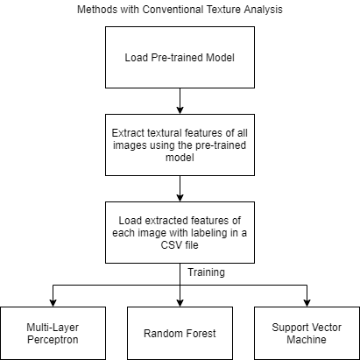

Figure 1. Flowchart of methods with texture analysis.

We loaded the pre-trained model (DenseNet201) and extracted textural features of each image into a CSV file. We labelled them into 0 and 1 for binary classification. Then we trained the data using MLP, Random Forest and SVM. On testing data we gained an accuracy of 51%, 67% and 68% for Random Forest, MLP and SVM respectively.

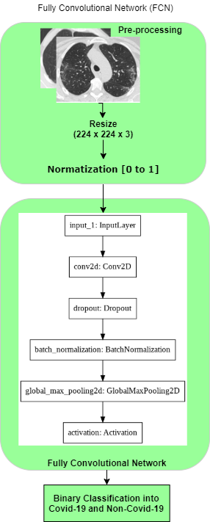

1. **Fully Convolutional Network**

We implemented a Fully Convolutional Network where

in the pre-processing step we resized the images of the

dataset into (224 × 224) image-size. After normalization,

the image dataset having two classes is then divided

into training and testing categories. Then training samples

are fed into a 2D convolution layer followed by Dropout(0.2),

Batch normalization, 2D global max pooling and a Softmax

Activation function is applied. Here, in this experiment,

Binary Cross entropy as a loss function and Stochastic gradient

descent are used. Only 51% accuracy is obtained on testing data.

1. **Weakly Supervised Deep Learning**

To implement weakly supervised learning. We kept our framework (KarNet) same and performed all the pre-processing steps as mentioned in our manuscript. We reduced the training sample from 80% to 60% for weakly supervised training purpose. We used DenseNet201 to train the model but obtained an accuracy of only 50%.

1. **Shallow Network**

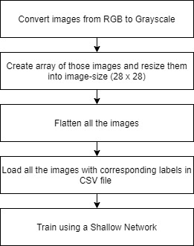

Figure 3. Flowchart of Shallow Network

As we have low computational power, for training on a shallow network, we first flattened the grayscale pixel values as features and made a CSV file with class labelling as mentioned in figure 3. We trained a Shallow MLP using Weka Software with 5 folds cross-validation but only 52% accuracy is obtained.

|  |  |  |  |  |  |  |
| --- | --- | --- | --- | --- | --- | --- |
| **Methods** | | **Accuracy** | **Precision** | **Recall** | **Specificity** | **F1-Score** |
| Methods with Conventional Texture Analysis | Multi-Layer Perceptron(MLP) | 67% | 0.74 | 0.57 | 0.79 | 0.70 |
| Random Forest | 51% | 0.53 | 0.41 | 0.62 | 0.55 |
| **Support Vector Machine(SVM)** | **68%** | 0.72 | 0.60 | 0.76 | 0.69 |
| Fully Convolutional Network(FCN) | | 51% | 0.51 | 1.00 | 0.00 | 0.67 |
| Weakly Supervised Deep Learning | | 50% | 0.50 | 1.00 | 0.00 | 0.67 |
| Shallow Network (MLP) | | 52% | 0.52 | 1.00 | 0.00 | 0.68 |

Table 1. Testing analysis using model trained on augmented SAR-Cov-2 lung CT-scan images using other alternative methods. The method with highest accuracy is bolded in the above table.

**Conclusion**: After the experimentation, highest accuracy of 68% is obtained using texture analysis method by SVM which is unsatisfactory when compared to transfer learning method where using proposed framework DenseNet201 achieved an accuracy of 97%. Hence, this result is not included in the final revision version of the paper.

For quick view of the reviewer, the result obtained using transfer learning method is demonstrated in below.

|  |  |  |  |  |  |
| --- | --- | --- | --- | --- | --- |
| **Model trained on non-Augmented Lung CT-scan image dataset** | | | | | |
| **Models** | **Accuracy** | **Precision** | **Recall** | **Specificity** | **F1-Score** |
| **DenseNet201** | 97% | 0.95 | 0.98 | 0.95 | 0.97 |
| **VGG16** | 97% | 0.96 | 0.98 | 0.96 | 0.97 |
| **ResNet50V2** | 96% | 0.97 | 0.94 | 0.97 | 0.96 |
| **MobileNet** | 96% | 0.95 | 0.97 | 0.94 | 0.96 |
| **Model trained on augmented Lung CT-scan image dataset** | | | | | |
| **DenseNet201** | 97% | 0.95 | 0.98 | 0.95 | 0.97 |
| **VGG16** | 94% | 0.95 | 0.94 | 0.95 | 0.94 |
| **ResNet50V2** | 96% | 0.95 | 0.97 | 0.95 | 0.96 |
| **MobileNet** | 95% | 0.94 | 0.96 | 0.93 | 0.95 |

Table 2. Testing analysis using model trained on non-augmented and augmented SAR-Cov-2 lung CT-scan images using Transfer Learning Method.

Q-3. Have the authors considered about overfitting problems as showing in Figure 4?

**Response:** Thank you for your query. Yes, we have addressed the overfitting problem. The below explanation is also highlighted in the revision version of the paper for quick view of the reviewer.

In the additional layers, the first average pooling layer is used, which is believed to take out the average values of the features from the feature maps. The 2D average pooling block reduces the size of the data, the number of parameters and amount of computation needed. Pooling also controls overfitting. Then the activations are flattened and two fully connected layers are added: the first layer with 128 nodes and the second with 64 nodes. To avoid overfitting a dropout layer is added in between these dense layers.

To have a diverse dataset and prevent overfitting data augmentation is performed for each training group of CT-scan images.

**Reviewer #2**  
  
Q-1. This manuscript lacks a review to other works that utilize transfer learning techniques to solve the problem of COVID-19 prediction.

**Response:** Thank you for your valuable advice. We improved the Related Work section in our revised version of the paper. For quick view it is highlighted in the revision version of the paper.

Q-2. The resolution of the figures and equations in this paper is too low, and the grammar needs further improvement.

**Response:** Thank you for your advice. We enhanced the resolution of all the figures and improved the grammar of the paper. For quick view it is highlighted in the revision version of the paper.

Q-3. If this paper can compare and analyze the performance of its own model and other transfer learning models in predicting the COVID-19, it will be more convincing.

**Response:** Thank you for your advice. We included a comparison table of performance of our model and other transfer learning models for diagnosis of COVID-19 using CT-Scan images. Here is the analysis with Reference in tabular format. For quick view it is also highlighted in the revision version of the paper.

|  |  |  |  |
| --- | --- | --- | --- |
| **Reference** | **Total CT-Scan Samples** | **Pre-trained Model** | **Accuracy** |
| Shah et al. [1] | 738 | VGG-19 | 94.52% |
| DenseNet169 | 93.15% |
| VGG-16 | 89% |
| ResNet50 | 60% |
| InceptionV3 | 53.4% |
| Bai HX et al.[2] | 118401 | EfficientNet B4 | 96% |
| H.S Maghdid et al.[3] | 339 | AlexNet | 82% |
| Angelov et al [4] | 2481 | VGG-16 | 94.96% |
| A.Jaiswal et al.[5] | 2481 | DenseNet201 | 96% |
| VGG-16 | 95% |
| Resnet 152V2 | 94.91% |
| Inception ResNet | 90.90% |
| Ours | 2481 | **DenseNet201** | **97%** |
| VGG-16 | 94% |
| ResNet50V2 | 96% |
| MobileNet | 95% |

Table 3. Comparison with other methods. All the above references used transfer learning based methodology to classify the CT-scan images as COVID-19 positive or negative with different accuracies according to the specific models. The highest accuracy and model is bolded in the above table.

**Above Reference Citations:**

1. Shah, V., Keniya, R., Shridharani, A., Punjabi, M., Shah, J., & Mehendale, N. (2021). Diagnosis of COVID-19 using CT scan images and deep learning techniques. *Emergency radiology*, 1–9. Advance online publication. <https://doi.org/10.1007/s10140-020-01886-y>
2. Bai, H. X. *et al.* AI Augmentation of Radiologist Performance in Distinguishing COVID-19 from Pneumonia of Other Etiology on Chest CT. *Radiology* 201491 (2020).
3. Maghdid, H.S., Asaad, A.T., Ghafoor, K., Sadiq, A.S., & Khan, M. (2020). Diagnosing COVID-19 Pneumonia from X-Ray and CT Images using Deep Learning and Transfer Learning Algorithms. ArXiv, abs/2004.00038.
4. Soares, Eduardo, Angelov, Plamen, Biaso, Sarah, Higa Froes, Michele, and Kanda Abe, Daniel. "SARS-CoV-2 CT-scan dataset: A large dataset of real patients CT scans for SARS-CoV-2 identification." medRxiv (2020).doi: <https://doi.org/10.1101/2020.04.24.20078584.>
5. Aayush Jaiswal, Neha Gianchandani, Dilbag Singh, Vijay Kumar & Manjit Kaur, Classification of the COVID-19 infected patients using DenseNet201 based deep transfer learning, Journal of Biomolecular Structure and Dynamics,2020, DOI:[10.1080/07391102.2020.1788642](https://doi.org/10.1080/07391102.2020.1788642)